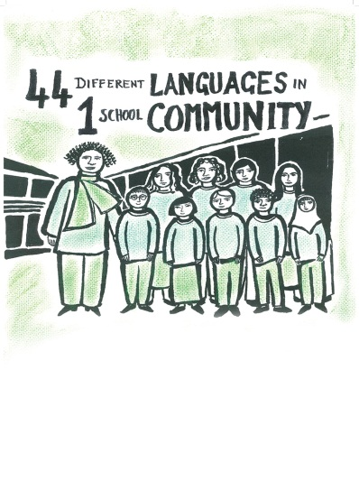

Floating and sinking
Word mat
Subject: | Science
Age groups: | Key stage 1
Topic: | Floating and sinking

This project and its actions were made possible due to co-financing by the European Fund for the Integration of Third-Country Nationals.

This project and its actions were made possible due to co-financing by the European Fund for the Integration of Third-Country Nationals.

This project and its actions were made possible due to co-financing by the European Fund for the Integration of Third-Country Nationals.

Floating and sinking word mat

top

bottom

The toy duck floats. The toy duck is light.
The rock sinks. The rock is heavy.

The toy duck floats on top of the water.
The rock sinks to the bottom of the bowl.
Appendix – Images in this resource

1. Fishbowl
Fishbowl http://www.publicdomainfiles.com/show_file.php?id=13534191016566
By J_Alves https://openclipart.org/
Available under Public Domain license. For more information see http://www.publicdomainfiles.com/browse.php?q=all&s=0&o=popular&a=13&m=all

2. Duck
Bath toy duck https://pixabay.com/vectors/bath-duck-rubber-toy-verbs-2022661/
By OpenClipart-Vectors https://pixabay.com/users/openclipart-vectors-30363/
Available under Pixabay license. For more information see https://pixabay.com/service/license/

3. Rocks
Rocks https://pixabay.com/photos/rocks-granite-limestone-stones-2485461/
By Msaeedsalem https://pixabay.com/users/msaeedsalem-5655159/
Available under Pixabay license. For more information see https://pixabay.com/service/license/

