Electrical circuits
Word bank
Subject: | Science
Age group: | 5 – 7, 8 - 11
Topic: | Electricity

This project and its actions were made possible due to co-financing by the European Fund for the Integration of Third-Country Nationals.

This project and its actions were made possible due to co-financing by the European Fund for the Integration of Third-Country Nationals.

This project and its actions were made possible due to co-financing by the European Fund for the Integration of Third-Country Nationals.

wire  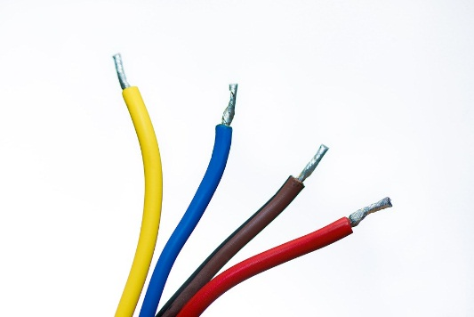 | bulb  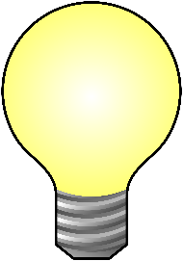 | battery  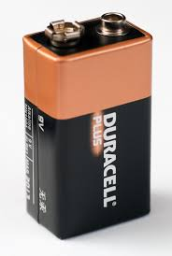
switch  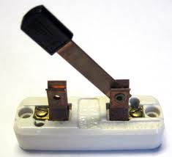 | crocodile clip  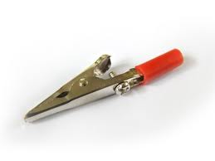 | circuit  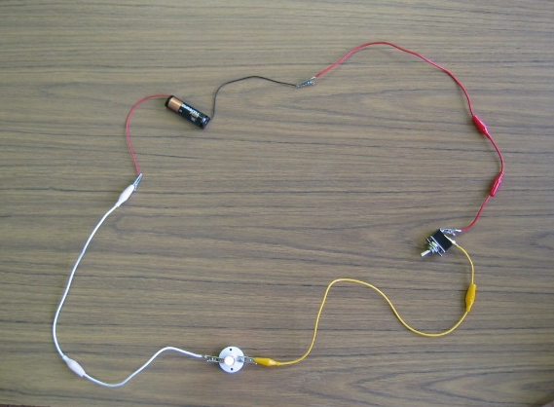

Image attributions
- Battery: https://en.wikipedia.org/wiki/Nine-volt_battery By Ashley Pomeroy (Own work) [CC BY 3.0 (http://creativecommons.org/licenses/by/3.0)], via Wikimedia Commons
- Bulb: https://commons.wikimedia.org/wiki/File%3ALight_bulb_icon.svg By Elembis (Own work) [Public domain], via Wikimedia Commons
- Circuit: By Ruth Wilson used with permission
- Crocodile clip: https://en.wikipedia.org/wiki/Crocodile_clip By Benjamint (Own work) [GFDL (http://www.gnu.org/copyleft/fdl.html) or CC-BY-SA-3.0 (http://creativecommons.org/licenses/by-sa/3.0/)], via Wikimedia Commons
- Switch: https://en.wikipedia.org/wiki/Knife_switch By AYL (Own work) [CC BY-SA 3.0 (http://creativecommons.org/licenses/by-sa/3.0)], via Wikimedia Commons
- Wire: https://pixabay.com/p-1080555/?no_redirect Public domain, no attribution required.

