EU_logo

**EAL Nexus resource**

This project and its actions were made possible due to co-financing by the European Fund for the Integration of Third-Country Nationals

This project and its actions were made possible due to co-financing by the European Fund for the Integration of Third-Country Nationals

|  |
| --- |
| Handa’s Surprise |

|  |  |
| --- | --- |
| **Word Mat** | |
| **Subject(s):** | **Literacy** |
| **Age group(s):** | **0-4, 5-7** |
| **Topic:** | **Speaking and Listening** |

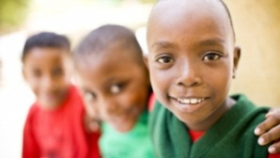

This project and its actions were made possible due to co-financing by the European Fund for the Integration of Third-Country Nationals.

This project and its actions were made possible due to co-financing by the European Fund for the Integration of Third-Country Nationals.

This project and its actions were made possible due to co-financing by the European Fund for the Integration of Third-Country Nationals.

Handa’s Surprise Word Mat

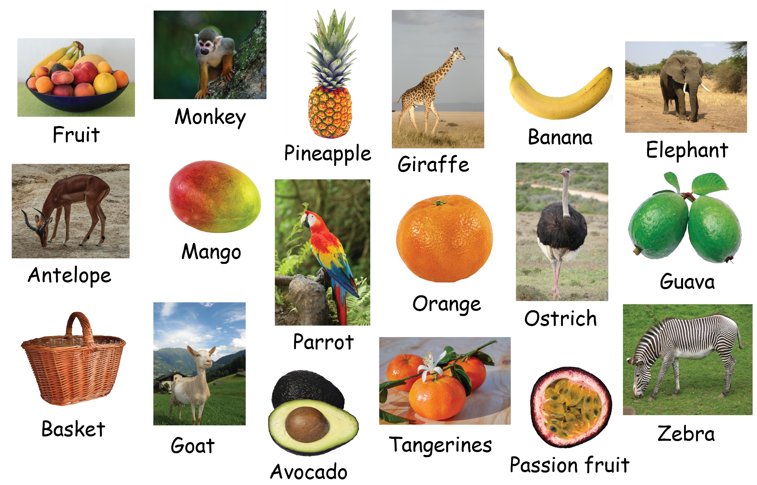

Images in this document

Page 2, Fruit fruit-bowl-fruit-basket-fruit (https://pixabay.com/en/fruit-bowl-fruit-basket-fruit-1517740/) By connie\_sf (https://pixabay.com/en/users/connie\_sf-1617884/)Available under a Creative Commons Public Domain Dedication (CC0 1.0) license. For more information see https://creativecommons.org/publicdomain/zero/1.0/deed.en

Page 2, Monkey scented-monkey-primate-animal-wild (https://pixabay.com/en/scented-monkey-primate-animal-wild-1200044/) By joelfotos (https://pixabay.com/en/users/joelfotos-767874/)Available under a Creative Commons Public Domain Dedication (CC0 1.0) license. For more information see https://creativecommons.org/publicdomain/zero/1.0/deed.en

Page 2, Pineapple pineapple-fruit-food-tropical (https://pixabay.com/en/pineapple-fruit-food-tropical-909097/) By Kaz (https://pixabay.com/en/users/Kaz-19203/)Available under a Creative Commons Public Domain Dedication (CC0 1.0) license. For more information see https://creativecommons.org/publicdomain/zero/1.0/deed.en

Page 2, Giraffe giraffe-tall-mammal-africa (https://pixabay.com/en/giraffe-tall-mammal-africa-171318/) By zgmorris13 (https://pixabay.com/en/users/zgmorris13-47586/)Available under a Creative Commons Public Domain Dedication (CC0 1.0) license. For more information see https://creativecommons.org/publicdomain/zero/1.0/deed.en

Page 2, Banana banana-fruit-yellow (https://pixabay.com/en/banana-fruit-yellow-1504956/) By Mooruk (https://pixabay.com/en/users/Mooruk-2887827/)Available under a Creative Commons Public Domain Dedication (CC0 1.0) license. For more information see https://creativecommons.org/publicdomain/zero/1.0/deed.en

Page 2, Elephant elephant-african-bush-elephant (https://pixabay.com/en/elephant-african-bush-elephant-114543/) By ajoheyho (https://pixabay.com/en/users/ajoheyho-37109/)Available under a Creative Commons Public Domain Dedication (CC0 1.0) license. For more information see https://creativecommons.org/publicdomain/zero/1.0/deed.en

Page 2, Antelope impala-buck-antelope-male-impala (https://pixabay.com/en/impala-buck-antelope-male-impala-448357/) By JamesDeMers (https://pixabay.com/en/users/JamesDeMers-3416/)Available under a Creative Commons Public Domain Dedication (CC0 1.0) license. For more information see https://creativecommons.org/publicdomain/zero/1.0/deed.en

Page 2, Mango mango-fruit-png-transparent-cutout (https://pixabay.com/en/mango-fruit-png-transparent-cutout-1218147/) By Ancelin (https://pixabay.com/en/users/Ancelin-1987740/)Available under a Creative Commons Public Domain Dedication (CC0 1.0) license. For more information see https://creativecommons.org/publicdomain/zero/1.0/deed.en

Page 2, Parrot birds-exotic-waterfall-hawaii (https://pixabay.com/en/birds-exotic-waterfall-hawaii-3555585/) By rebth1st (https://pixabay.com/en/users/rebth1st-9620843/)Available under a Creative Commons Public Domain Dedication (CC0 1.0) license. For more information see https://creativecommons.org/publicdomain/zero/1.0/deed.en

Page 2, Orange fruit-clementine-png-orange-citrus (https://pixabay.com/en/fruit-clementine-png-orange-citrus-1222438/) By Ancelin (https://pixabay.com/en/users/Ancelin-1987740/)Available under a Creative Commons Public Domain Dedication (CC0 1.0) license. For more information see https://creativecommons.org/publicdomain/zero/1.0/deed.en

Page 2, Ostrich bouquet-south-africa-bird-ostrich (https://pixabay.com/en/bouquet-south-africa-bird-ostrich-2124991/) By ah-layout (https://pixabay.com/en/users/ah-layout-950781/)Available under a Creative Commons Public Domain Dedication (CC0 1.0) license. For more information see https://creativecommons.org/publicdomain/zero/1.0/deed.en

Page 2, Guava jambu-guava-leaf-green-guava (https://pixabay.com/en/jambu-guava-leaf-green-guava-png-2836033/) By Pakjen (https://pixabay.com/en/users/pakjen-5851928/)Available under a Creative Commons Public Domain Dedication (CC0 1.0) license. For more information see https://creativecommons.org/publicdomain/zero/1.0/deed.en

Page 2, Basket basket-shopping-basket-isolated (https://pixabay.com/en/basket-shopping-basket-isolated-1710064/) By Gellinger (https://pixabay.com/en/users/Gellinger-201217/)Available under a Creative Commons Public Domain Dedication (CC0 1.0) license. For more information see https://creativecommons.org/publicdomain/zero/1.0/deed.en

Page 2, Goat goat-in-austria-austria-goat (https://pixabay.com/en/goat-in-austria-austria-goat-198455/) By Pixel-Sepp (https://pixabay.com/en/users/Pixel-Sepp-69900/)Available under a Creative Commons Public Domain Dedication (CC0 1.0) license. For more information see https://creativecommons.org/publicdomain/zero/1.0/deed.en

Page 2, Avocado avocado-sliced-avocado-slice (https://pixabay.com/en/avocado-sliced-avocado-slice-1287100/) By StevenGiacomelli (https://pixabay.com/en/users/StevenGiacomelli-2218761/)Available under a Creative Commons Public Domain Dedication (CC0 1.0) license. For more information see https://creativecommons.org/publicdomain/zero/1.0/deed.en

Page 2, Tangerines tangerines-clementines-fruit (https://pixabay.com/en/tangerines-clementines-fruit-3114765/) By Couleur (https://pixabay.com/en/users/Couleur-1195798/)Available under a Creative Commons Public Domain Dedication (CC0 1.0) license. For more information see https://creativecommons.org/publicdomain/zero/1.0/deed.en

Page 2, Passion fruit Passion fruit (https://www.publicdomainpictures.net/en/view-image.php?image=12539&picture=passion-fruit) By klaus beyer  (https://www.publicdomainpictures.net/en/browse-author.php?a=10844)Available under a Creative Commons Public Domain Dedication (CC0 1.0) license. For more information see https://creativecommons.org/publicdomain/zero/1.0/deed.en

Page 2, Zebra zebra-zoo-black-and-white-striped (https://pixabay.com/en/zebra-zoo-black-and-white-striped-9928/) By PixelAnarchy (https://pixabay.com/en/users/PixelAnarchy-555/)Available under a Creative Commons Public Domain Dedication (CC0 1.0) license. For more information see https://creativecommons.org/publicdomain/zero/1.0/deed.en