**EAL Nexus resource**



This project and its actions were made possible due to co-financing by the European Fund for the Integration of Third-Country Nationals

|  |
| --- |
| Dulce et Decorum Est |

|  |  |
| --- | --- |
| **Exploring the content by paraphrasing** | |
| **Subject(s):** | **English, History** |
| **Age group(s):** | **12 to 14, 15 to 16** |
| **Topic:** | **War poetry** |

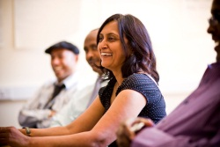

This project and its actions were made possible due to co-financing by the European Fund for the Integration of Third-Country Nationals.

This project and its actions were made possible due to co-financing by the European Fund for the Integration of Third-Country Nationals.

This project and its actions were made possible due to co-financing by the European Fund for the Integration of Third-Country Nationals.

**Exploring the content of the poem**

This is what a soldier remembers.

Which heading is best for each part?

|  |
| --- |
| Nightmare |
| Gas attack |
| Soldiers after the battle on their way back |
| What seeing a soldier dying can teach you |
| A dying man being transported from the front |

Write the headings in.

|  |
| --- |
|  |
| When someone shouted ‘Gas!’ every soldier tried to put their gas masks on as quickly as they could. The helmets were not easy to fit. One soldier did not manage to fit his gas mask. I could hear him shout; then he moved as if he were drowning in water. I could not see him clearly because there was condensation on my gas mask and the air was like thick green fog. I saw how the soldier fell to the ground. |
|  |
| The soldier was thrown onto a cart. The soldiers who walked behind the cart could see how blood came out of his mouth whenever the cart went over a stone or a hole in the ground. The blood came from the soldier’s lungs, which were destroyed by the gas. The blood coming out of his mouth was like the food cows bring up. It was very unpleasant, like wounds that can never heal on the tongues of people who had not done anything wrong. |
|  |
| We moved with our backs bent. We coughed a lot and cursed because we were angry about having to walk through thick mud. When we saw the flares, we turned back and slowly moved to our camp. We were very tired. Some of us walked without our boots with our feet covered in blood. We had lost our boots on the battlefield and had difficulty walking. We moved without noticing anything around us, not even the gas bombs which were being dropped by the enemy. |
|  |
| If you walked behind the cart seeing this dying soldier, you would not tell young war enthusiasts that it is ‘sweet and honourable’ to die for their country because this is a lie. |
|  |
| Since that day I have seen the dying soldier in my dreams – how he could not breathe anymore and fell to the ground. |

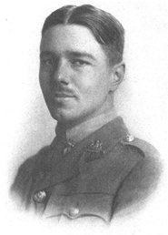

Write down in a sentence what the writer wants the readers to learn from his experiences.

|  |
| --- |
|  |
|  |
|  |